**ANNA UNIVERSITY, CHENNAI – 600 025.**

**DEPARTMENT OF INFORMATION SCIENCE AND TECHNOLOGY**

**MCA (Regular) 3 – YEAR PROGRAM**

**BATCH – 2**

**AutoRoute Navigator For Blind People  
Using SLAM**

Name : Ganesh Prasad K Guide

Register No: 2019202011 Ms. S.KANIMOZHI

Teaching Fellow

**Abstract**

AutoRoute Navigator is a system for visually impaired people using sound for navigation. To obtain that there is a need for computer vision-based techniques, that to it must match the human perspective. Vision-based techniques are used in many domains like convenience stores, driverless car testing, daily medical diagnostics, monitoring the health of crops, and also in navigation systems. AutoRoute Navigator is capable of routing an individual that too for the visually impaired it helps a lot by providing with the basic instructions (ie. take left, take right, move straight). As an existing technology like the ZebraX app, Beacon Systems uses its kind of navigation methods. AutoRoute Navigator uses voice output to generate ideas about the size and distance of the obstacle, thus creating a safe path for navigation towards the destination. The goal is to create a system without using any additional devices. Instead, blind people can use their mobile phones to enable their movement without assistance.

**Introduction (Domain)**

Localization and Mapping is the computational problem of constructing or updating a map of an unknown environment. It can be accomplished using SLAM (**S+L+A+M** = **Simultaneous** + **Localization** + and + **Mapping**) algorithms. It based on concepts in computational geometry and computer vision, and are used in robot navigation, robotic mapping and odometry for virtual reality or augmented reality. As existing technologies like Beacon (Bluetooth Technology) used for indoor navigation, but it need external hand-held device to navigate. SLAM don’t need any kind of addition devices it can be implemented with our mobile camera. The visually impaired students can use their mobile to navigate inside a classroom.

**Problem Statement**

* To recognize the different type of obstacles inside a classroom
* To route a visually impaired student outside/inside a classroom

**Objective**

* Create a web application for visually impaired students to assist and navigate them inside a class room.
* This application can be accessed by our normal mobile camera itself, no need of any additional device.

**Architecture Diagram**

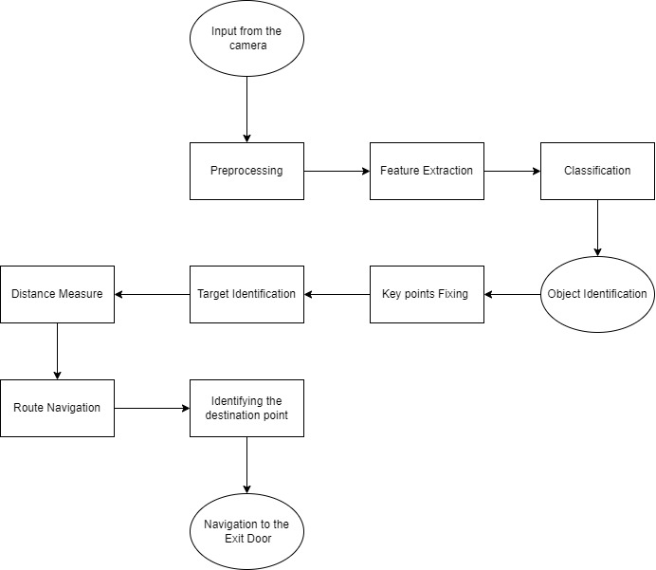

**Architecture Explanation**

* Using our mobile camera real world objects are detected.
* Images were taken into individual frames and segmented.
* The Features from the image are extracted and classified.
* The Objects are identified and Targets are identified.
* Distance between the User and Target are identified.
* Route to the destination is identified and conveyed to the used as audio output.

**List of Modules**

* Obstacle Detection
* Target Identification
* Distance Calculation
* Route Navigation

**Brief Description of Modules**

* Obstacle Detection
  + Real world objects are identified
  + Objects are classified and labeled
* Target Identification
  + Destination points are identified
* Distance Calculation
  + Distance calculates between user and target.
* Route Navigation
  + Best route to the destination is identified and conveyed as audio output.

**References**

<https://www.researchgate.net/publication/331294969_Mobile_Phone_Sensing_using_the_Built-in_Camera>

<https://www.researchgate.net/publication/220299606_Indoor_Positioning_and_Navigation_with_Camera_Phones>

<https://ieeexplore.ieee.org/stamp/stamp.jsp?arnumber=8416714>

**Guide Signature**

**(S.KANIMOZHI)**